FlowCuro v2
A Clinical Flow Cytometry File Handling System

Contents
Notice 2
1. Introduction 3
2. Technical specifications 3
I. Minimal system requirements: 3
3. Procedures 3
I. FlowCuro Lab 3
Directory structure 3
Overview of procedures 5
II. FlowCuro Clinical 7
Buttons: 8

Notice
-------------------------------------------------------------------------------
FlowCuro - Clinical Flow Cytometry File Manager
FlowCuro Lab (clinical laboratory technician user) and FlowCuro Clinical (pathologist user)

Author: German Campuzano Zuluaga
Created: September 9 2013 Miami FL
Version: Version: 2
License: THIS IS AN UNLISCENCED SOFTWARE.
Copyright: (c) German Campuzano-Zuluaga 2013
Support: gcampuzanozuluaga@med.miami.edu
Version 2 changes:
1. FlowCuro Lab. Adds path for backup: C:\Program Files\BD FACSCanto Software\SetupReport
2. FlowCuro Lab. Fixes regex for Copath and Sunquest files
3. FlowCuro Lab. Modifies global variables

This software is for exclusive use of the Jackson Memorial Hospital and University of Miami Health System Department of Pathology.
-------------------------------------------------------------------------------

Introduction
FlowCuro is software designed to backup raw “experiment”, *.FCS, “SetupReport” and *.PDF files while at the same time maintaining a directory architecture that allows for pathologists to access remotely, keep track and manage the PDFs generated for clinical analysis. FlowCuro consist of two independent programs:
- FlowCuro Lab: This program creates a backup for all the raw data files and clinical PDF files, makes clinical PDF files available in case type-specific directories and removes old files from both the local flow cytometers computer and from the network drive used for file backup and clinical PDF file handling.
- FlowCuro Clinical: This is program with a graphic user interphase (GUI) that will connect remotely to a designated network drive and will display a dynamic list of the cases available for pathologist to sign-out.
FlowCuro facilitates file and directory management and makes file transfer from a local machine to a network drive an easy, quick and reliable process.

Technical specifications
Developed using Python 2.7
Executable file compiler: PyInstaller 2.0 (http:\\www.pyinstaller.org)

Minimal system requirements:
- FlowCura Lab:
  - Windows XP or superior (only tested systems)
  - 14.5 MB of disk space
- FlowCura Clinical:
  - Windows XP, or superior (only tested systems)
  - 31.3 MB of disk space

Procedures

FlowCuro Lab
FlowCuro is currently only designed to work with the BC FacsDiva software directory structure. A network drive is required for the backup and clinical case PDF file handling. The PATH to the network drive is coded as a variable in the source code for FlowCuro Clinical; any change in the PATH must be updated in the source code.
The following directories are required for FlowCuro to run on a local (flow cytometers) PC and a network drive:

Directory workflow and architecture (Figure 1 and 2)

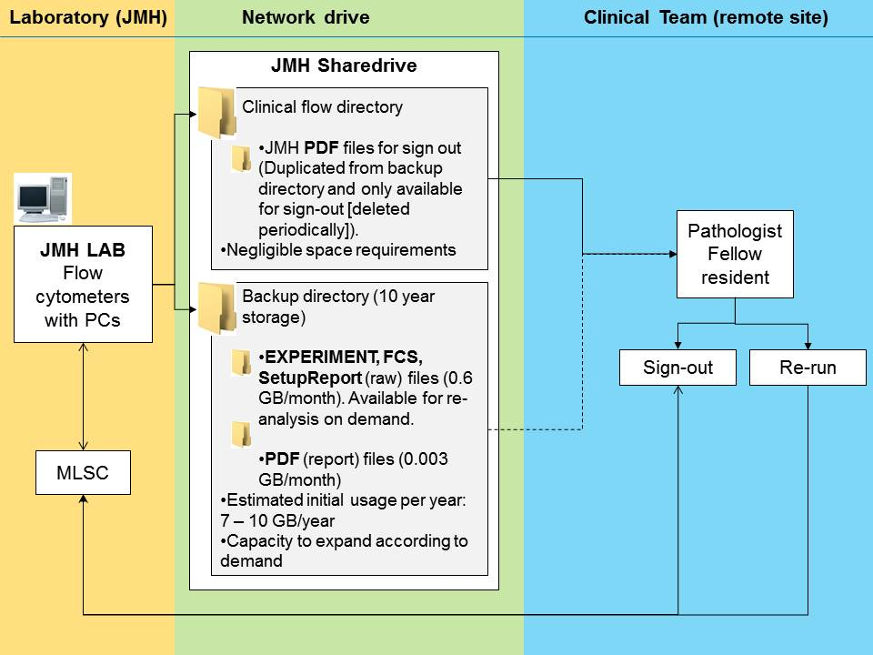
Figure 1. Workflow schema.
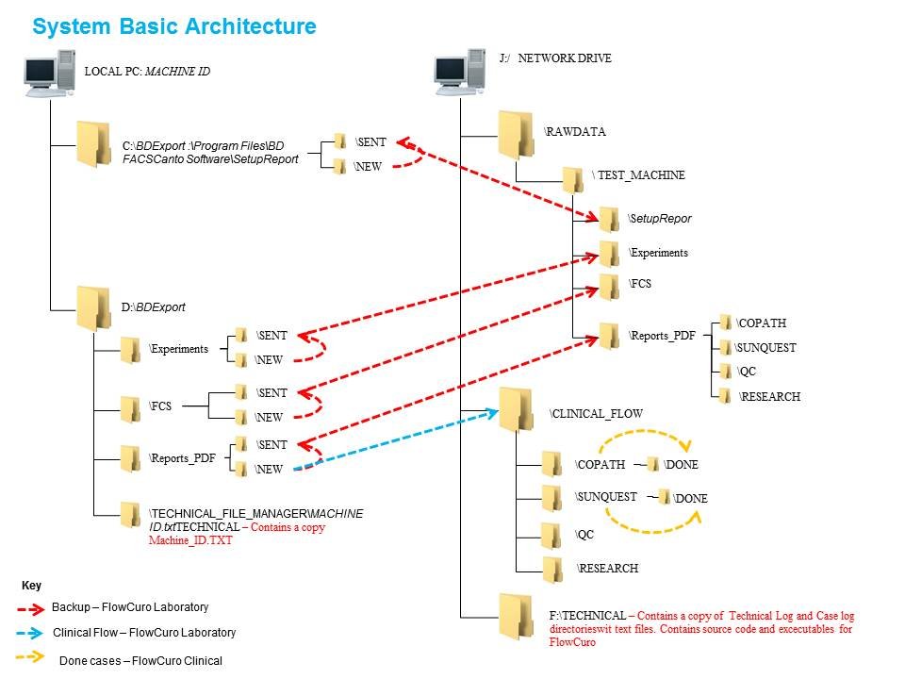
Figure 2. Directory architecture

Key:
*THE USER MUST CREATE THE PATHS
**THE USER MUST NOT CREATE THE PATHS (THESE WILL BE CREATED BY THE PROGRAM)

Local PC

*Incoming files from cytometer to local drive:
Experiment files/folders: “D:\BDExport\Experiments\NEW"
FCS files/folders: “D:\BDExport\FCS\NEW"
Setup Report files/folders: “C:\Program Files\BD FACSCanto Software\SetupReports\NEW"
PDF files: “D:\BDExport\REPORTS_PDF\NEW"

*Temporary storage for files sent to net-drive (files automatically deleted in 90 days):
Experiment files/folders: “D:\BDExport\Experiments\SENT"
FCS files/folders: “D:\BDExport\FCS\SENT"
Setup Report files/folders: “C:\Program Files\BD FACSCanto Software\SetupReports\SENT"
PDF files: “D:\BDExport\REPORTS_PDF\SENT"

**Technical folder and file:
Machine ID: “D:\BDExport\TECHNICAL_FILE_MANAGER\MACHINE ID.txt”

Network Drive
The network drive must be previously mapped to the letter “J” on the local flow cytometers PC. The folders in the network drive will be created during the first run of the program on the flow cytometers PC. During this first run the entire directory structure will be created along with two text files where the program run log and clinical case log (network drive) will be written and a third text file with the Machine ID (local PC). During the first run the user will be prompted to enter the machine’s name (user defined); this will create a file that will be read by the program to determine the adequate path for a machine-specific backup. This machine ID will appear in the paths below as “machine”. The backup files will be organized by year (final directory in path labeled below as “year”).

**Backup (ten year storage – manual deletion):
Experiment file backup: “J:\BACKUP\" + machine + "\RAWDATA\EXPERIMENTS" + year
FCS file backup: “J:\BACKUP\" + machine + "\RAWDATA\FCZ" + year
Setup Report file backup: “J:\BACKUP\" + machine + "\RAWDATA\SETUP_REPORTS" + year
CoPath case PDF backup: “J:\BACKUP\" + machine + "\REPORTS_PDF\COPATH" + year
Sunquest case PDF backup: “J:\BACKUP\" + machine + "\REPORTS_PDF\SUNQUEST" + year
Research case PDF backup: “J:\BACKUP\" + machine + "\REPORTS_PDF\RESEARCH" + year
QC PDF backup: “J:\BACKUP\" + machine + "\REPORTS_PDF\QC" + year

**Clinical Use (one year storage – automated deletion at 370 days):
CoPath case PDFs: “J:\CLINICAL_FLOW\COPATH”
Finished CoPath case PDFs: “J:\CLINICAL_FLOW\COPATH\DONE”
Sunquest case PDFs: “J:\CLINICAL_FLOW\SUNQUEST"
Finished Sunquest case PDF: “J:\CLINICAL_FLOW\SUNQUEST\DONE"
Research case PDFs: “J:\CLINICAL_FLOW\SUNQUEST\RESEARCH"
QC PDFs: “J:\CLINICAL_FLOW\SUNQUEST\QC"
Finished CoPath case PDFs: “J:\CLINICAL_FLOW\COPATH\DONE”

**Techincal folder and file:
Backup and case transfer log for machine: “D:\TECHNICAL\FILE_ADMIN_LOG\”+ machine FLOW_CASES_LOG_" + machine + "_" + year + ".txt"
General clinical case transfer log: “D:\TECHNICAL\CASE_LOG\TECH_CASE_LOG_"+ year + ".txt"

Overview of procedures
- Machine ID: Once the program is executed the script will first search for the machine ID file (read above); if the file with the machine ID is not available, the program will prompt the user to designate a name for the machine currently running (user defined). On subsequent runs the machine ID will be used to create the path (variables in the source code) to backup of the files to the network drive.
- Backup: The program will search for files and directories that are older than 24 hours in the local “experiment”, “FCS”, “setup report” and “PDF” directories and will make a copy of these files and directories to the corresponding directory by year in the network drive. The backup is done from files that are in the temporary storage directory ($\SENT). This means that invalid PDF files (explained ahead) will not be sent to the network drive unless they are corrected as they will remain in the incoming folder ($\NEW) of the local PC.
- Local PC space management: Files and directories in the temporary storage directory ($\SENT) in the local PC that are >90 days old will be deleted. Every time a file is deleted, the program checks that the file has been effectively backed-up in its corresponding network drive directory.
- Network drive space management: Files and directories in Clinical_Flow directory (Copath, Sunquest, Reaseach and QC) will be permanently deleted after 370 days. A permanent copy of these files is in the PDF backup directory for each machine (read ahead). These backup files must remain at least 10 years by CAP regulation. If space is required, these file may be manually deleted if they become >10 year old.
- Clinical case transfer: A temporary directory (one year cycle) system holds all the PDFs generated that are required for clinical evaluation, research or QC. All PDFs that are transferred to the network drive go to two places: a backup file system by machine, and clinical flow case system (Clinical_flow). The Clinical_Flow directory contain subdirectories for Copath, Sunquest, Research and QC cases. FlowCuro Clinical program reads files from this Clinical_Flow file system. Cases will only be transferred from the local machine incoming directory (“D:\BDExport\REPORTS_PDF\NEW”) if the case is labeled adequately as follows:
  - Copath cases:
    - Pattern: [Accession number w\wo part] [name] [TS|FL|BM|PB] [type of test] [serial number][.pdf]
    - Regular expression: "(\D{1,2}\d{2}-{1}\d+\w{0,})\s+(\w+-{0,1}\w+)\s+((?:BM)|(?:PB)|(?:TS)|(?:FL))\s+(\w+\d*)\s+\d+(?=.pdf)"
    - Examples: M13-767 SMITH FL LY1 20130807111102.pdf
M13-443A ARCILA BM LE2 20130805111211.pdf

  - Sunquest cases:
    - Pattern: [Accession number w\wo part] [name] [TS|FL|BM|PB] [type of test] [serial number][.pdf]
    - Regular expression: "([MTXWFHS]\d+\w{0,})\s+(\w+-{0,1}\w+)\s+((?:BM)|(?:PB)|(?:TS)|(?:FL))\s(\w+\d*)\s+?\d+(?=.pdf)"
    - Examples: M12767 SMITH PB LE1 20130807111102.pdf
F44322A ARCILA PB LE2 20130805111211.pdf

  - Research cases:
    - Pattern: [ANYTHING][RXH][ANYTHING][.pdf]
    - Regular expression: "(.*RXH.*).pdf"
    - Examples: RXH M12767 SMITH PB LE1 20130807111102.pdf
RXH F44322A ARCILA PB LE2 20130805111211.pdf
  - Research cases:
    - Pattern: [ANYTHING][QCF][ANYTHING][.pdf]
    - Regular expression: "(.*QCF.*).pdf"
    - Examples: QCF M12767 SMITH PB LE1 20130807111102.pdf
QCF F44322A ARCILA PB LE2 20130805111211.pdf
- Logs: FlowCuro Lab will create two logs as follows:
  - Technical log: This is a machine-specific log that creates an entry each time the program runs and displays the following information (Figure 3):
    - Number of backed up Experiment, FCS and Setup Reports files or directories.
    - Number and name of files older than 370 days deleted from Clinical_Flow folder in the network drive.
    - Number and name of files older than 90 days deleted from %SENT folders on local machine.
    - Number and name of PDF clinical files transferred to respective backup folders and Clinical_Flow folders.
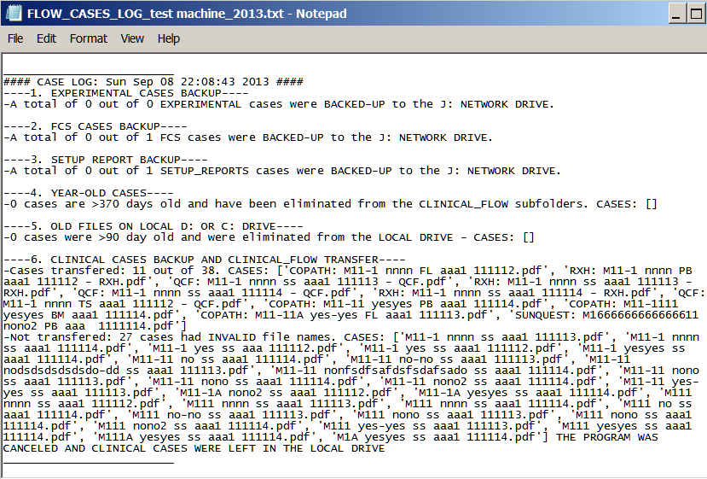
Figure 3. Screen shot of the Technical Log.
  - Clinical case transfer log: This is a single log where clinical cases (Copath and Sunquest) cases are logged independently of the machine where the sample was ran. This case log is a coma-delimited text file (*.CSV) that can be used for turn-around-time calculations. Each time the program transfers clinical cases the following variables will be written into the case log:
    - File name, accession number, patient name, matrix, panel name, date, hour

FlowCuro Clinical
FlowCuro Clinical is a simple program with a GUI that will display clinical cases available in the Clinical_Flow Copath and Sunquest directories. Currently, FlowCuro Clinical only has a tab for Jackson Memorial Hospital (other tabs may be added in the source code) (Figure 4). The main hospital tab will contain two sub-tabs, one for Copath pathology cases and another one for Sunquest clinical laboratory cases (Figure 4). Within the Pathology sub-tab there will be a list with tissue cases that includes both tissue and fluid flow cytometry PDFs; and a bone marrow list that includes bone marrow and peripheral blood flow cytometry PDFs. Cases are sorted into either one of these two list by the matrix type (tissue list: matrix = TS or FL; bone marrow list: Matrix = BM or PB) using the regular expressions shown above. The Clinical Lab. sub-tab will contain a single list of cases in the Sunquest folder (Figure 5).
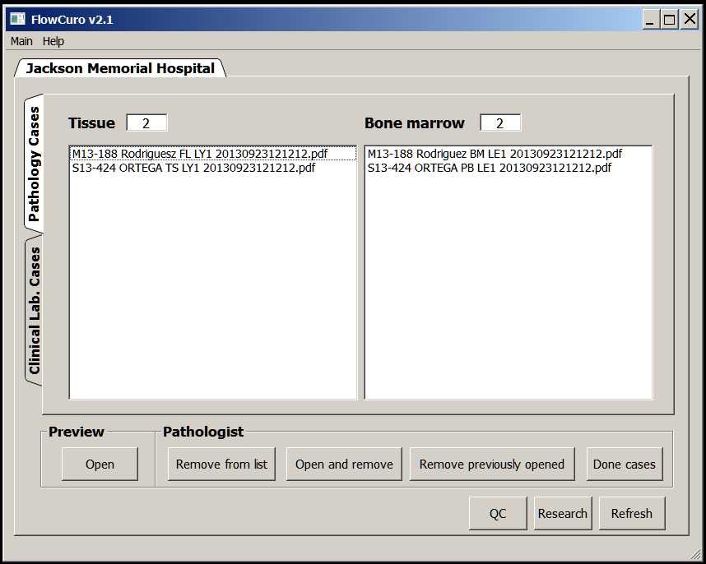
Figure 2. Pathology Cases (Copath). Tissue list: matrix = TS or FL; Bone marrow list: Matrix = BM or PB
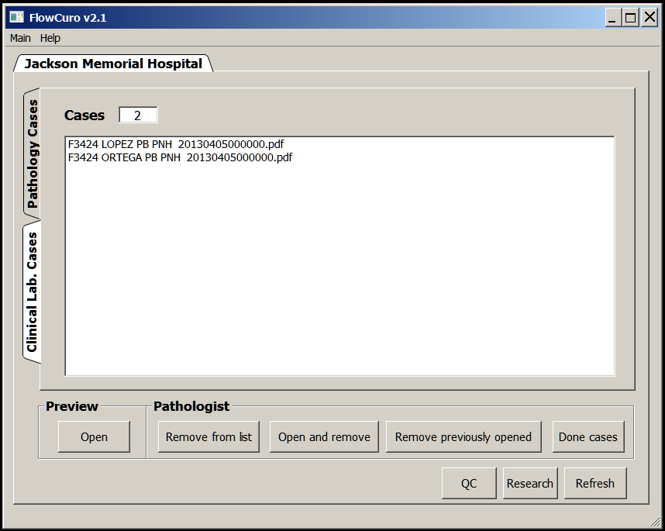
Figure 2. Clinical Lab. Cases (Sunquest)

Buttons:
- Open: open selected case.
- “Remove from list”, “Open and remove”, “Remove previously opened”: removed cases will be sent to the “Done” folder within the $Clinical_Flow/CASE-TYPE (CASE-TYPE = COPATH or SUNQUEST) directory. They will remain there for 370 days until they are automatically deleted. To display these cases again in FlowCuro Clinical just paste them back into the $Clinical_Flow/CASE-TYPE folder
- “Done cases”: opens the $Clinical_Flow/CASE-TYPE/Done folder for both Copath and Sunquest
- QC: Opens the $Clinical_Flow/QC folder
- Research: Opens the $Clinical_Flow/research folder

